Taking probe hit on gear tooth vectoring in at Pressure and Helix angles. Vectors change when applied.

I: 20° pressure angle SIN 0.34202

J: 21.9316° Helix SIN 0.37349

K: 21.9316° Helix COS 0.92763

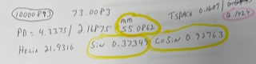

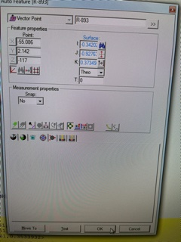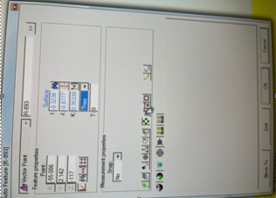

Left side is wanted vectors, right side is after it’s applied. The vectors change. WHY?