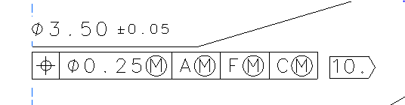

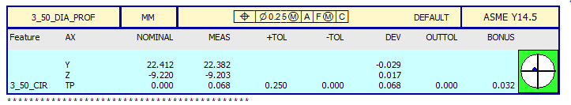

Datum A is a flat surface.

Datum F is a thru hole.

Datum C is a flat surface.

A and C are perpendicular to one another.

Datum F and the 3.50mm hole go thru Datum C.