**WIN7/WIN10 PCDMIS 2016 and newer Permission Settings**

Due to the way WIN7/WIN10 security works the following steps need to be done to make sure PCDMIS and the operator both have the proper permissions to run the software. Administrative permissions are required to do the following. If you are doing a fresh install it is best to have the operators’ login brought up to the level of Administrator. Then do the PCDMIS install under his login and when the installation/configuration of PCDMIS is done their permissions can be brought down to the standard user/users group level, if needed.

**After PCDMIS is installed and configured the following permissions need to be set:**

1. **You must have administrative permissions to do the following steps.**

* If you cant do a particular step, get IT involved and have them raise your administrative level. There are different levels of Administrator. “Quotes” are used extensively in this document. When doing the steps never type the quote signs into Windows.

2. **Make sure you can view hidden files and folders.**

* Open Windows Explorer,
* In the top left corner select “Organize”
* Select “Folders and search options”
* Select the “View” tab
* Check “Show hidden files, folders, and drives”,
* Uncheck “Hide empty drives in the computer folder”
* Uncheck “Hide extensions of known file types”
* Select “Apply”
* Select “OK” to close window

3. **Turn off User account control in WIN7/WIN10**

* Click on the Windows start button in the lower left corner.
* In “Search program and files” type “UAC”
* Select “Change User Account Control settings”
* Lower the slide bar to “Never notify”
* Select “OK”
* Select “Yes” to allow changes
* If the PC asks for a reboot wait until all the steps have been completed in this document and then reboot.

4. **Set registry permissions for PC-DMIS and Datapage+, if installed.**

* Click on the Windows start button in the lower left corner.
* In the “Search programs and files” Type in “Regedit” and hit enter.
* Now navigate to the registry entry  Hkey_local_machine\software\Wow6432node\ Hexagon or WAI(PCDMIS 2015.1) (for 64 bit PC’s ) For 32 bit PCDMIS the path is Hkey_local_machine\software\ Hexagon.
* Right click on the Hexagon or WAI entry and select “Permissions…”
* Scroll down the list of “group or usernames” and select “users”
* Check the box for “full control-allow” and hit apply and OK then go to 4B below.
* ***IF* you do not have a “users” section to modify:**
* Select “Add…”
* Under “Enter the object names to select” type “users” (without quotes),
* Select “Check Names”
* When it underlines the name “users” select “OK”.  If it does not underline the name see Appendix A below.
* You will be returned to the “Security” tab
* Under the “Permissions for users” select the check box for “Full control” under “allow”, this also checks the “Read” box, leave it checked.
* Select “Apply”
* Select “OK”
* 4B: Also set “users” to have permissions in these Registry entries as well: HKEY_CURRENT_USER\Software\ Hexagon or WAI (for 2015.1) (32-bit & 64 bit) and HKEY_USERS\.Default\Software\ Hexagon or WAI (for 2015.1)
* Close the Registry Editor

5. **To allow all users read/write privileges to three different PCDMIS folders:**

* Open Windows Explorer
* Navigate to the “C:\Program Files (X86)\ Hexagon” folder or the “C:\Program Files\ Hexagon” folder, depending on where PCDMIS was installed. WAI folder for 2015.1.
* Right click on the Hexagon folder
* Select “Properties”
* Select the “Security” tab
* Select “Edit”
* IF the Users group is not there, do the following, if it is there just set users to have full control.
* Select “Add”
* Under “Enter the object nam1es to select” type “users”(without quotes)
* Select “Check Names” If you get “Name not found” error, hit cancel and go to Appendix A below for instructions on how to add Users
* When it underlines the name “users” select “OK” DESKTOP-XXXXXXXXXX\Users
* Windows returns you to the Security tab
* Under “Permissions for users” check the box for “Full control” under “Allow”, this also checks the “Modify” box, leave it checked
* Select “Apply”
* Select “OK”
* Select “OK” again to get out of the WAI properties screen.
* Do this also for the C:\ProgramData\ Hexagon or WAI folder, if you get an “Access is denied” error, press continue
* Also do it for the C:\Users\Public\Public Documents\ Hexagon or WAI folder, if you get an “Access is denied” error, press continue

6. THIS STEP IS NOT NEEDED FOR WIN10:**To allow the shortcuts for PCDMIS, Setting Editor and Datapage+ to run under administrative rights:**

* Click on the Windows start button in the lower left corner.
* All Programs
* Open “PC-DMIS XXXX” folder
* Hover over the “PC-DMIS XXXX online” icon
* Right click on the online icon
* Select “Properties”
* Select “Compatibility” tab
* Select “Change settings for all users”
* Check “Run this program as an administrator”
* Select “Apply”
* Select “OK”
* Select “OK” again to close out of PCDMIS properties
* Do the same thing for the Settings Editor and Datapage+ icons under the Windows Start, All Programs path.

7. **Power options now need to be set:**

* Click on the Windows start button in the lower left corner.
* In “Search programs and files” type “power options”, hit enter
* Balanced or Dell should be checked, select “change plan settings”
* Change “Put the computer to sleep” to “never”
* Change “Turn off the display” to “30 minutes”
* Select “Change advanced power settings”
* Expand “Hard disk”
* Expand “Turn off hard disk after”
* Change “Setting (Minutes)” to 0, this sets it so the hard disk never turns off
* Expand “USB settings”
* Expand “USB selective suspend setting”
* Change from “Enabled” to “Disabled”
* Expand “PCI Express”
* Expand “Link State Power Management”
* Change the settings from “Moderate power savings” to “Off”
* Select “Apply”
* Select “OK”
* Select “Save changes”
* WIN10 specific setting: go under “choose what the power buttons do”, click “change settings that are currently unavailable”, under “shutdown settings” make sure “turn on fast startup” is disabled.
* Close out the “Power Options” window.

8. **Performance settings now need to be set:**

* Its up to you whether to do this step or not, if you think the PC has enough power to run PCDMIS then you can skip this step.
* Click on the Windows start button in the lower left corner.
* In “Search programs and files” type “Performance info”
* Select “Performance Information and Tools”
* Select “Adjust visual effects”
* Select “Adjust for best performance”
* Select “Apply”
* Select “OK”

9. **Create a shortcut of PCDMIS and Datapage+ for all operators**

* Go to C:\program data\Microsoft\Windows\Start menu \programs folder\PC-DMIS XXXX 64bit folder and copy the online and offline shortcuts, if applicable to c:\users\public\desktop.

10. **Modify the following settings in the Settings editor:**

* Click on the Windows start button
* Select All Programs
* Click on PCDMIS XXXX and select PCDMIS XXXX Settings Editor
* The Settings Editor pops up, click on “connect…”
* After the window populates click on “find…”
* Type in LockExpiryReminder and click find next
* Click on the + sign to expand the settings
* Click on “Disabled” and change setting to True
* Press save
* Now search for DoNotUseAmyUniRTF
* Change that value from 0 to 1
* Select save and then close out the settings editor.
* Change “AutoCheckForUpdates” to False, PCDMIS 2018 and up is using a “Hexagon Universal Updater” app to update pcdmis automatically. this is up to you to turn this setting off. If it’s a core product you are doing these WIN10 permissions on then it should be ok for the customer to install any new updates BUT if you are on a non core product ie Zeiss, LK, Mitutoyo ETC I would definitely change this to False.

To turn off the updater, you have to uninstall it from “programs and features” in Windows.

Appendix A:

* If the users is not found, under “Select Users, Computers, Service Accounts, or Groups” hit the “Locations” button.
* Select the name of the PC, this will be the very top selection and should have an icon like this:

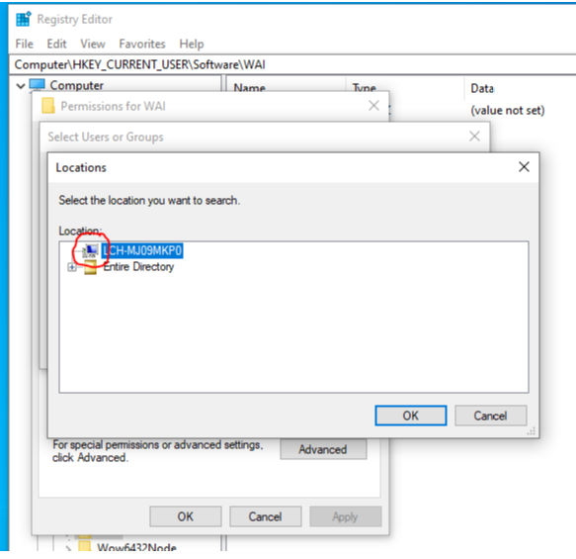

* Hit ok
* Under “enter the object names to select” type Users
* Hit ok
* You should then be able to give full control to the Users group
* Apply and OK out.