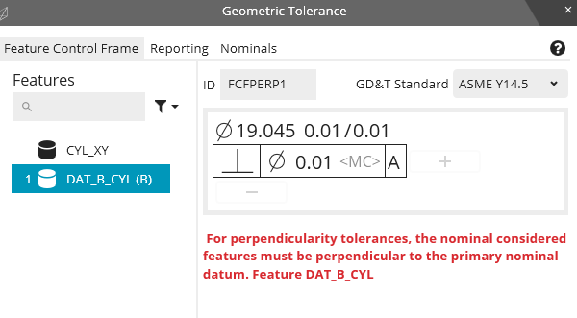

Datum A Plane (A)

Datum B Cyl (B)