Registry Keys requiring Read/Write/Modify privileges, (FULL).

Select start all programs Accessories Run

In the run box type in regedit and select ok

Below are the paths you will need to add the user for full read permissions:

**Please note:** in 2016.0 and newer “WAI” is Replaced by “Hexagon”

HKEY_LOCAL_MACHINE\SOFTWARE\Wow6432Node\WAI

HKEY_LOCAL_MACHINE\SOFTWARE\WAI

HKEY_USERS\.Default\Software\WAI

Add each user manually by clicking on Add type in the name search and ok now highlight the name in the top box and check full control and apply and ok

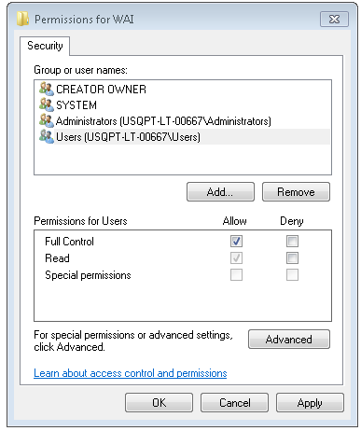

Specific users can be added, (click on Add… button.

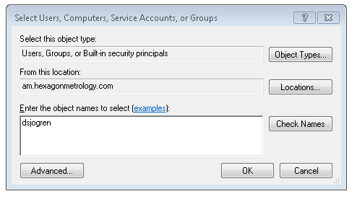

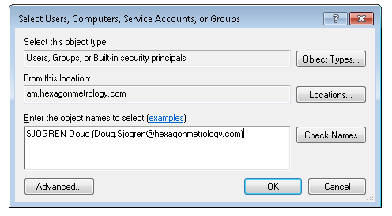

In some cases I have had to use Domain Users.

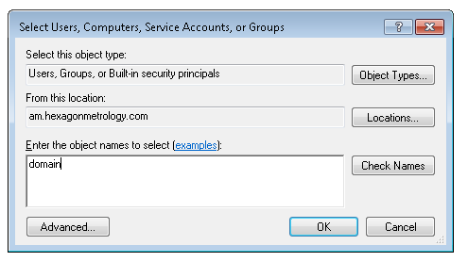 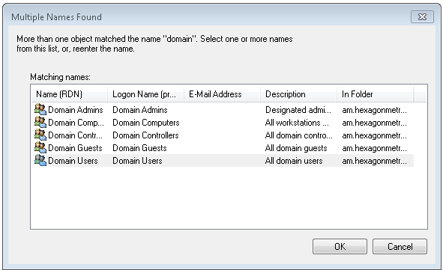

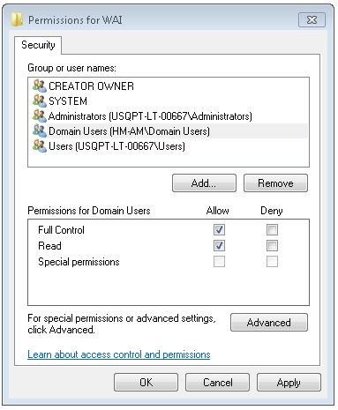

Path entries – the difference is just in application path. 32 bit OS/32bit APP, 64 bit OS/32Bit APP, & 64 bit OS/64 bit APP.

Same

Windows 7 Paths

32 bit OS

C:\Program Files\WAI

C:\Users\Public\Public Documents\WAI

C:\ProgramData\WAI

64 bit OS

32 bit APP

C:\Program Files (x86)\WAI

C:\Users\Public\Public Documents\WAI

C:\ProgramData\WAI

64 bit APP

C:\Program Files \WAI

C:\Users\Public\Public Documents\WAI

C:\ProgramData\WAI

Same controls as registry permissions, slightly different route.

Right-click folder, Properties – Security.

Highlight user – Edit, (modify or Add)

