**Rigid Region Method**

These commands are used for choosing the method for determining the nodes in the so-called rigid region.

The rigid region defines the integration region for the J-integral evaluation.

Consider the model below with a 2-D crack. If the rigid region is defined by the elements in red (actually, the nodes of the elements in red), then the integration of the J-integral is performed in the green elements. By defining the rigid region you decide which elements will contribute to the J-integral calculation: the elements connected to a node in the rigid region but not entirely in the rigid region. Since the J-integral is theoretically path independent for elastic materials we should get the same results regardless of how the rigid region is defined (as long as there are no other cracks in the rigid region).

**IMPORTANT:**. The rigid region must not involve nodes on the boundary, other than the nodes of the crack faces. In this example the rigid region could be defined as the red and green area but not larger (except to the right, where one extra line of elements could be used).

It is called the rigid region since an interpretation of the calculation method is that the nodes of the rigid region are rigidly shifted and the strain energy in the surrounding elements is calculated.

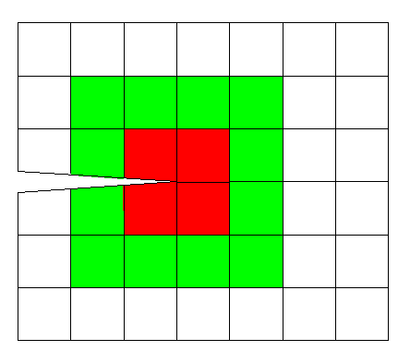

**Automatic (Topology Search):**

A number of rigid regions of increasing size is automatically determined using the mesh topology (connectivity). The number of regions to define is controlled by the **Rigid Regions** button.

**2-D**

The first region consists of the nodes of all elements connected to the crack tip (the elements in red in the picture above). The next region consists of the nodes in the previous region plus the nodes of all elements connected to a node in the previous region (red plus green). If the multiple tip nodes option is used, the first region will consist of all elements connected to any node within the distance tolerance.

**3-D**

The mesh around the crack front should consist of a regular mesh of hexahedral elements, typically created by extruding a 2-D mesh along the crack front. The rigid regions are created similarly to 2-D, but it is done for each crack front node separately and the regions grow radially from the crack front using only nodes on element faces. For a regular mesh, this creates a disk of nodes perpendicular to the crack front. This will give local values of the J-integral along the crack front.

**Automatic (Geometry Search):**

A number of rigid regions of variable size is determined by specifying a radius. The number of regions to define is controlled by the **Rigid Regions** button.

**2-D:**

The rigid region is defined as the nodes inside a circle of a given radius. In order to obtain the red rigid region in the picture above then the radius should be slightly larger than the diagonal of the element. Multiple rigid regions with different radii can be defined.

**3-D:**

The rigid region is defined as the nodes inside a cylinder of a given radius and a relative length along the crack front. The relative length given is a fraction of the distance between the current crack front node and the previous and next node, respectively. The end points of the axis of the cylinder are on the crack front at the positions defined by the relative length. This allows a similar type of rigid regions as for the topology based search to be defined for irregular meshes. The same radius and relative length are used for all nodes along the crack front.

**Manual:**

The nodes of the rigid region are explicitly given by the user. If a list of elements is available, use the **Select Nodes by Elements** option in the **Select** menu.