Direction heating on cylinder – free free expansion results

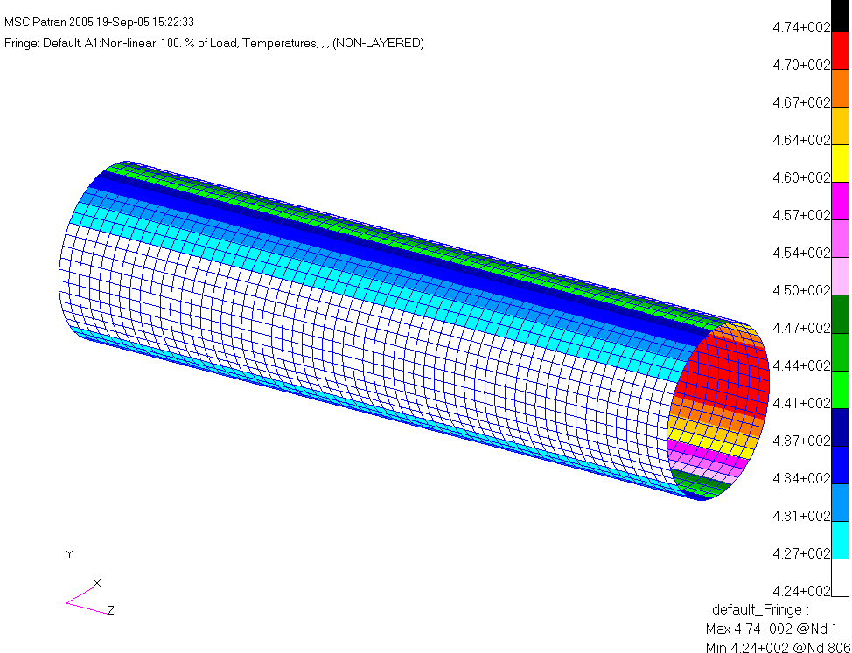
Figure 1: Temperature distributions

NASTRAN test deck for heat transfer run: cylinder_heat.bdf
cylinder_heat.bdf

NASTRAN output:
cylinder_heat.f06

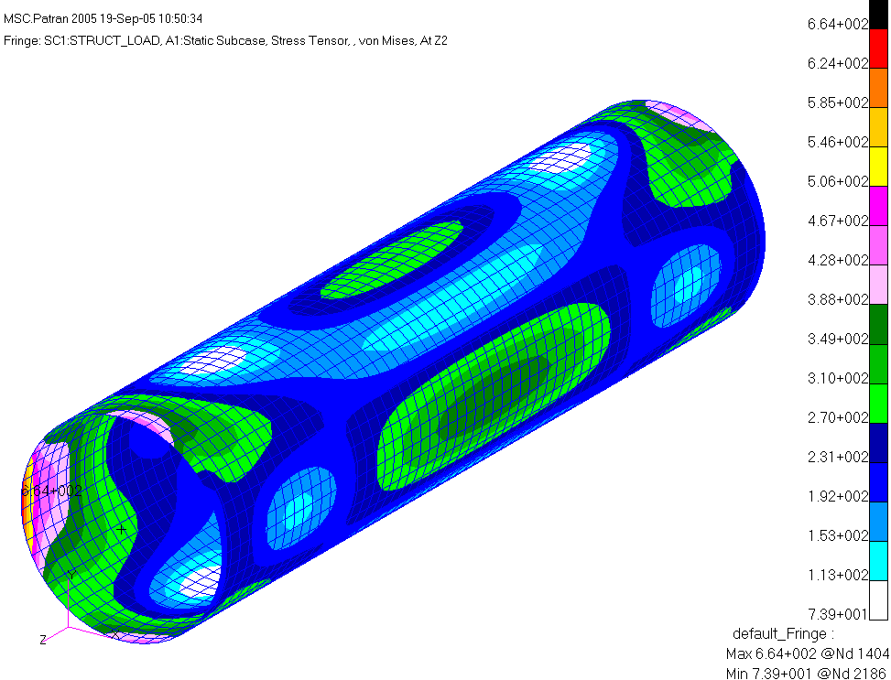
Figure 2: free free expansion due to the non-uniform heating

NASTRAN test deck: ws15_inrel2.dat
ws15_inrel2.dat

NASTRAN F06 file:
ws15_inrel2.f06

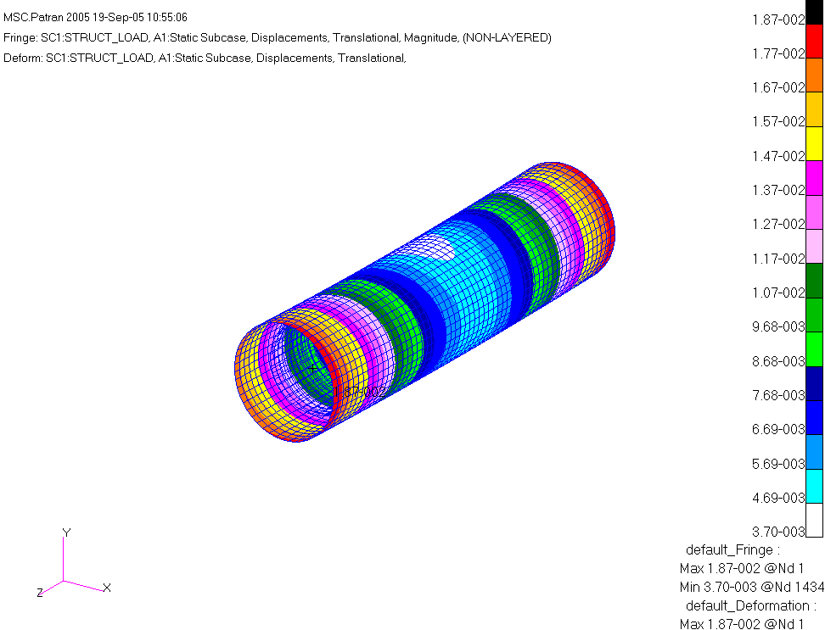
Figure 3: Displacement plot

PARAM,INREL,-2

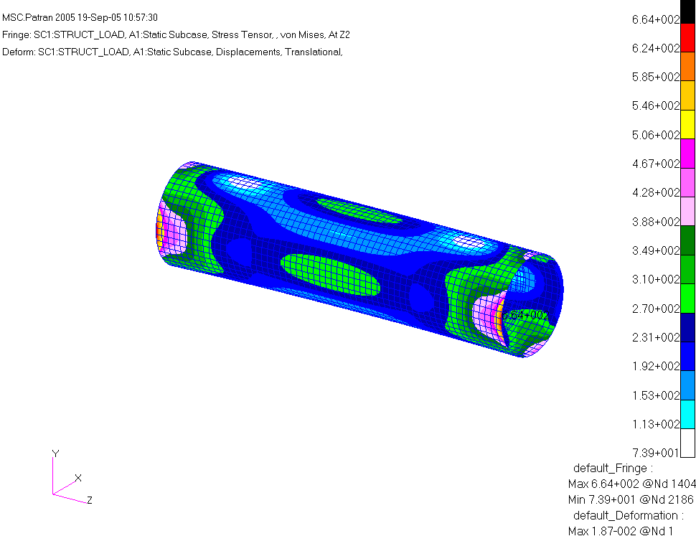
Figure 4: maximum stress along the edges

Instead of using PARAM,INREL,-2, the use imposed the minimum constraints to prevent the rigid body motion.

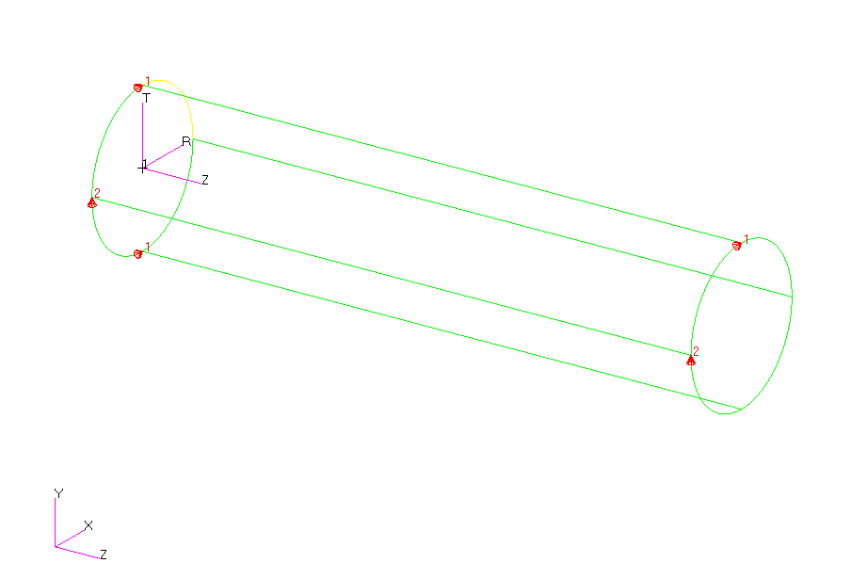
Figure 5: use 1 and 2 to constraint the rotations in Rz,and Rx

The two points in X direction on the left end prevent rotation in Z direction.
The two points in Y direction prevent rotation in X direction.
The two points in X at either end of the cylinder prevents rotation in Y direction.
We need to add one more z constraint to prevent the rigid body motion along the z direction.
The natural choice is at the center of the cylinder ,on node 403.

NASTRAN Test deck: cylinder_stress3.bdf
cylinder_stress3.bdf

NASTRAN F06 file:
cylinder_stress3.f06

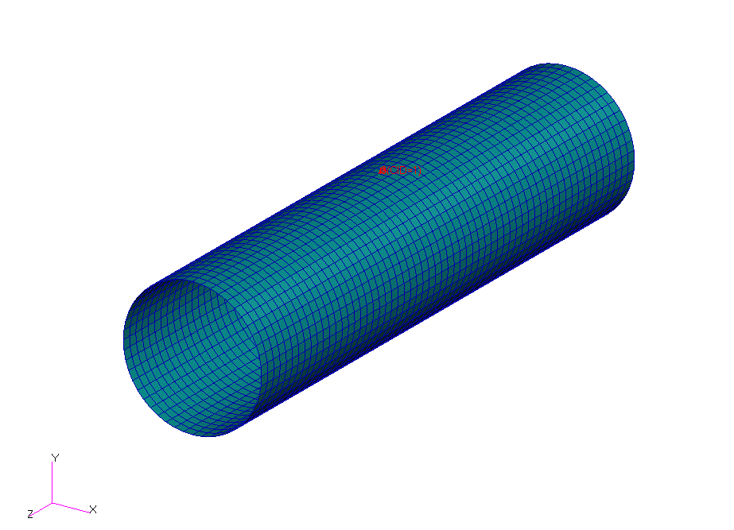
Figure 6: the z constraint(on node 403)
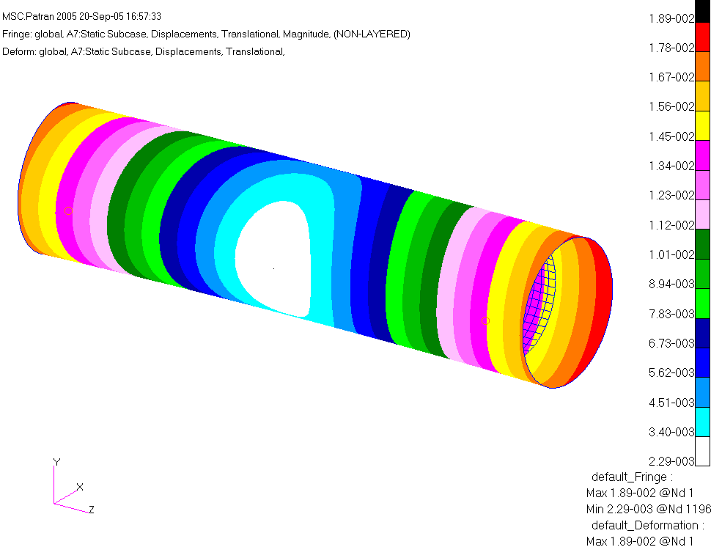
Figure 7: Displacement plot

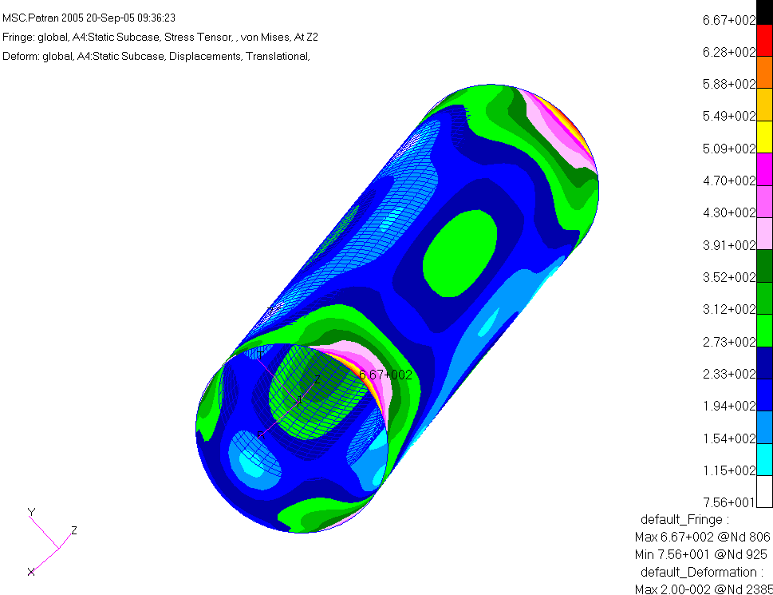
Figure 8: stress contour due to temperature gradients

The reaction forces should equal to zero if one imposed the correct boundary conditions.

F O R C E S O F S I N G L E - P O I N T C O N S T R A I N T

POINT ID. TYPE T1 T2 T3 R1 R2 R3
13 G 1.211902E-10 0.0 0.0 0.0 0.0 0.0
403 G 0.0 0.0 -2.139160E-10 0.0 0.0 0.0
793 G -4.973799E-12 0.0 0.0 0.0 0.0 0.0
806 G 0.0 -1.659828E-11 0.0 0.0 0.0 0.0
1586 G 0.0 2.320633E-11 0.0 0.0 0.0 0.0
1599 G -5.638867E-11 0.0 0.0 0.0 0.0 0.0

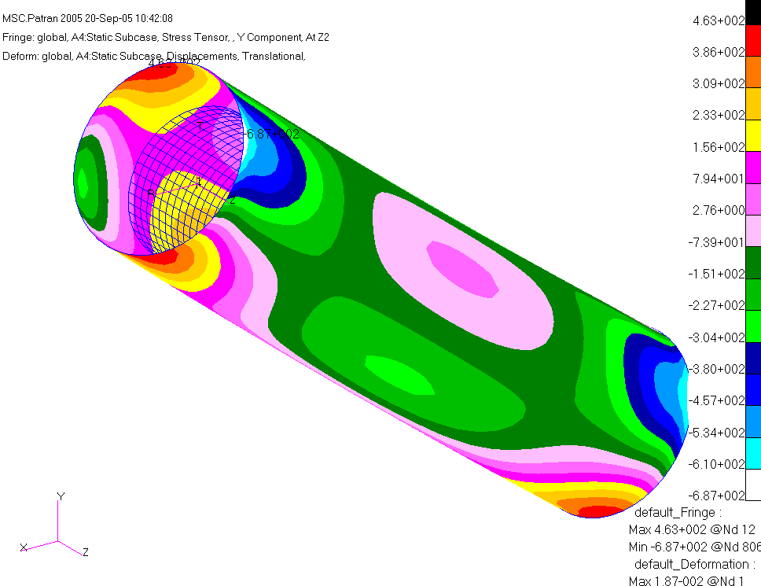
Figure 9:Hoop stress(stress in y direction,theta)

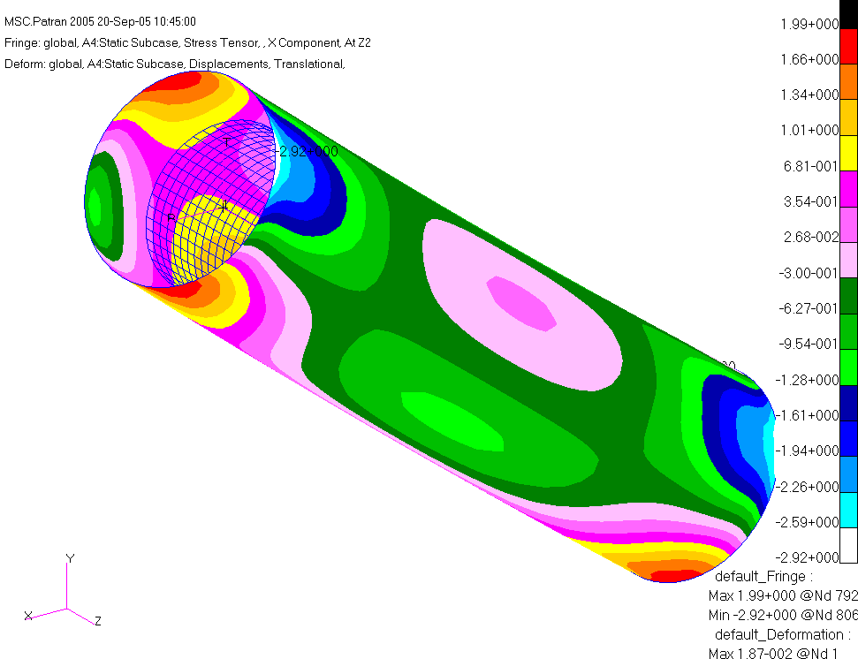
Figure 10:Radial stress

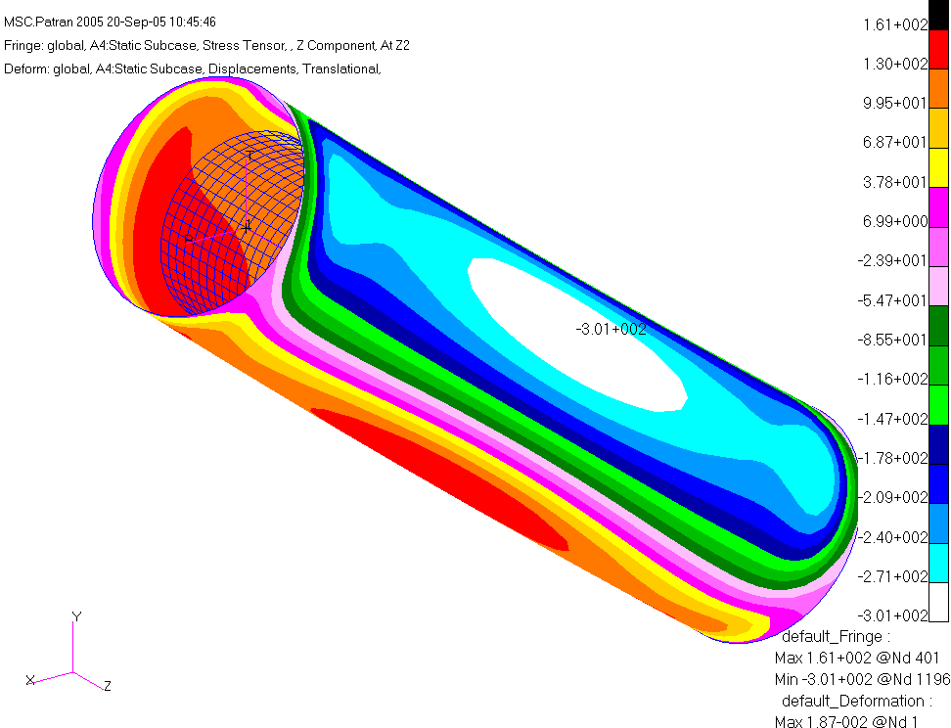
Figure 11: Stress in z direction

